NOTICE OF NW SECTOR COMMUNITY PLANNING MEETING
Wednesday, March 5, 2025 at 6:00PM
Timberlin Creek Elementary School
555 Pine Tree Lane
St. Augustine, FL 32092
NOTICE IS HEREBY GIVEN that a community meeting will be held on Wednesday March 5th, at 6:00 PM at Timberlin Creek Elementary School, 555 Pine Tree Lane, St. Augustine, FL 32092.
This community meeting is being held to allow the public an opportunity to learn about and participate in the planning for the Deer Park Boat & RV Storage proposal. The subject property is ±10.62 acres located on the south side of County Road 210 W, between Shearwater Parkway and South Hampton Club Way.
Request for a Small-Scale Comprehensive Plan Amendment CPA(SS) 2024-13 and PUD (PUD 2024-12) to change the Future Land Use designation of approximately 10.62 acres of land from Rural/Silviculture (R/S) to Business and Commerce Park (BC) and the zoning to PUD to allow for various non-residential use to be developed on the property.
For additional information, please contact Matthew Lahti, P.E. at 904-794-4231 or matt@gulfstreamdesign.com.
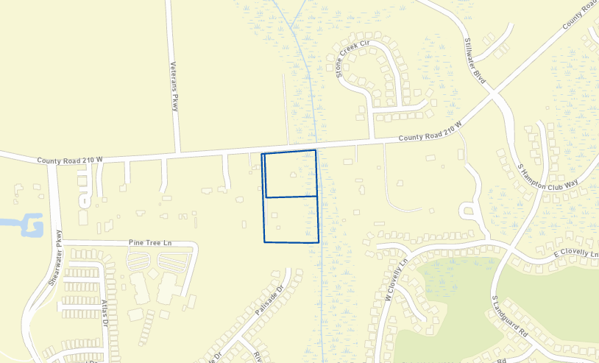
NOTICE TO PERSONS NEEDING SPECIAL ACCOMMODATIONS AND TO ALL HEARING IMPAIRED PERSONS: In accordance with the Americans with Disabilities Act, persons needing special accommodations to participate in the proceeding should contact the Applicant’s representative, Matthew Lahti, P.E. at 904-794-4231 or matt@gulfstreamdesign.com. For hearing impaired individuals: Florida Relay Service: 1-800-955-8770, no later than five (5) days prior to the date of the public community meeting.

