**Monthly Shelter Statistics for (August) (2024)**

Effective July 1, 2013, the Florida State Legislature passed data reporting requirements of all public and private animal shelters, humane organizations or animal control agencies operated by a humane organization, or by a county, municipality, or other incorporated political subdivision. St Johns County Animal Control has operated with transparency on sheltering data, including intake and euthanasia records, since the agency's inception.

Although the State is requiring all agencies to compile data into specific categories, the law does not define the individual classifications. In order to avoid subjectivity, St Johns County has defined the required categories. These definitions are specific to St Johns County and may not be applicable to other counties.

St Johns County encourages reporting transparency for all animal welfare organizations, including those not required by law. Only through collaborative collection of data from every organization and individual involved in animal sheltering and rescue, will we achieve a true and accurate accounting of animal welfare in each community

**Species Category**

**Dogs** - All domestic dogs, including neonates, including captured/trapped feral dogs.

**Cats** - All domestic cats, including neonates, including captured/trapped feral cats.

**Other** - All other animals, including livestock, exotic pets, birds, wildlife, etc.

**Intake Category**

**Surrendered by Owner** - Any animal surrendered to the shelter by the owner or designee, including those for bite quarantine; excludes those surrendered after being 'Confiscated',; excludes those surrendered/transferred in from other animal shelters, agencies and/or rescues.

**Stray** - Animals whose owner is unknown, including those with possible, but unverified, owner information; excludes those transferred from other animal shelters, agencies and/or rescues.

**Impounded** - Owned animals sheltered for Bite Quarantine, Dangerous/Vicious Dog investigation,

Special Hold cases (evictions, crime scenes, owner being arrested or being taken to hospital, domestic violence holds, or any other legal situation that results in a requirement for sheltering).

**Confiscated** - Owned animals seized as part of an animal cruelty and/or neglect investigation, including animal hoarding.

**Transferred from within Florida** - Any animal transferred into the shelter by other local Florida animal shelters, agencies, rescues, etc., regardless of ownership status.

**Transferred into or imported from out of state** - Any animal transferred into the shelter by other animal shelters, agencies, rescues, etc., originating outside of Florida, regardless of ownership status.

**Born in shelter** - Any animal born at the shelter.

**Disposition Category**

**Adoption** - Any animal adopted to the general public.

**Reclamation by Owner** - Any animal reclaimed by the owner or designee.

**Transfer to another public or private animal shelter, humane organization** - Any animal adopted or permanently transferred to another shelter or rescue organization, including injured/orphaned wildlife transferred to licensed wildlife rehabilitators.

**Death in kennel** - All animals that died at shelter or in transit, including trauma cases.

**Euthanasia at the owner's request** - Any sick, injured, or dangerous animal euthanized at the request

of the owner.

**Euthanasia** - Any animal euthanized, including unadoptable animals and sick/injured animals that no rescue or other shelter would accept, excluding euthanasia service requests for personally owned sick, injured, or dangerous animals.

**Released in field/Trapped, Neutered, Released (TNR)** - Any animal released from shelter by staff as part of a TNR program.

**Lost in care / missing animals or records** - Any animal stolen or escaped from shelter or from foster

Parent

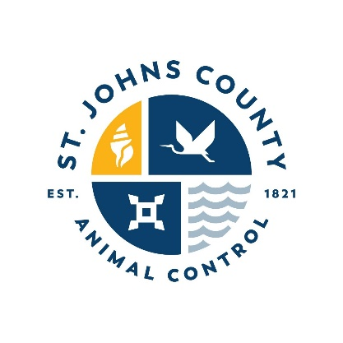**Ending inventory / shelter count at end of last day of the month** - All animals in shelter population at the end of the last day of the month, including those in foster homes.

**st. johns County**

Department of aNimal Control

130 North Stratton Road

St. Augustine, Florida 32095

**Monthly Shelter Statistics for (August) (2024)**

Monthly Shelter Reporting Required by section 823.15, Florida Statute

Current as of (Date) at (Time)

|  |  |  |  |
| --- | --- | --- | --- |
|  | **Dogs** | **Cats** | **Other** |
| **Live Animal Intakes** | **108** | **141** | **1 rat** |
| **Surrender by Owner** | **48** | **33** |  |
| **Stray** | **41** | **95** |  |
| **Impounded** | **19** | **13** |  |
| **Confiscated** |  |  |  |
| **Born in Shelter** |  | **0** |  |
| **Transfer from Within Florida** | **0** | **0** |  |
| **Transfer in from Outside Florida** | **0** | **0** |  |

|  |  |  |  |
| --- | --- | --- | --- |
| **Animal Outcomes** |  |  |  |
| **Adoption** | **32** | **77** |  |
| **Reclaimed by Owner** | **44** | **7** |  |
| **Death in Kennel/Custody** | **0** | **2** |  |
| **Owner Requested Euthanasia** | **21** | **8** |  |
| **Transfer to Another Shelter/Rescue** | **6** | **35** |  |
| **Euthanasia** | **19** | **51** |  |
| **Released in Field/TNR** | **0** | **0** |  |
| **Ending Inventory/Monthly Count** | **33** | **35** |  |